ATM FRAUD DETECTION MODEL
Project Overview:
An Australian bank is losing money and reputation due to fraudulent ATM transactions. This project aims to build a real-time fraud detection system that can flag suspicious transactions before they are completed.
The system uses multiple datasets, including customer transaction data, group information, and computed scores (Geo_scores, Instance_scores, Qset_stats, Lambda_wts), to predict fraud accurately.
Business Objective:
- Detect fraudulent ATM transactions with high accuracy.
- Minimize false positives to avoid inconveniencing legitimate customers.
- Deliver a reliable, production-ready model that can be applied to unseen data.
Data Overview:
Dataset | Rows | Columns | Contents
Geo_Scores | 1,424,035 | 2 | Id, Geo_Score
Instance_Scores | 1,424,035 | 2 | Id, Instance_Scores
Qset_Stats | 1,424,035 | 2 | Id, Qsets_Normalized_Tat
Lambda_Wts | 1,400 | 2 | Group, Lambda_Wt
Train | 227,845 | 28 | Features + Target
Test_Share | 56,962 | 27 | Features Only
Final_Target_Value | 56,962 | 1 | Target Column For Test Dataset
Key Features:
The dataset includes masked transaction variables plus proprietary engineered features:
- geo_scores: Location-based risk indicators
- Lambda_wts: Proprietary risk weighting index
- Qset_tats: Network turnaround time metrics\
- instance_scores: Vulnerability qualification scores
- Additional masked variables: Transaction-specific attributes (anonymized for privacy)
Data Loading and Initial Setup:
- The datasets were very large, so I converted them from CSV to Parquet.
- Parquet loads faster and uses less memory.
- Loading 1.4 million rows in CSV was slow, but Parquet was quick.
- I saved and reloaded the files, checked the shapes, and everything was ready.
- I thought, it’s a huge data so I need to be careful not to crash my computer.
I created a function called Basic_analysis to check data types, nulls, and duplicates. Observations:
- - Geo_scores had 71,543 null values in geo_score and 55,349 duplicates.
- - Instance_scores had 33,600 duplicates.
- - Qset_stats had 103,201 nulls and 59,311 duplicates.
- - Train and Test datasets were clean, no nulls or duplicates.
- I removed exact duplicate rows, keeping the first one.
- For missing values, I filled -500 and added flag columns (0 = not missing, 1 = missing).
- After cleaning, the datasets were smaller and trustworthy.
- For example, Geo_scores nulls dropped from 71,543 to 65,129.
- Outliers were Not Removed, as extreme values might show fraud.
- I felt: "Cleaning this way keeps all important signals for the model"
Challenges while Merging:
- Merging the datasets was tricky. Directly merging train with others exploded rows from 227,845 to over 5 million, crashing my system!!.
- The issue was repeating IDs in large datasets like Geo_scores.
- So ,I created base tables with unique IDs or Groups with first entry as True, then merged train and test using left joins.
- The final dataset had 284,807 rows and 34 columns.
- I dropped the 'id' column and renamed the test target to 'Target'.
- This approach kept the data safe and preserved all important information.
Simple steps:
- Removed only exact duplicate rows.
- Created flag columns for missing values before filling them.
- Kept outliers to preserve important information.
- Merged using unique base tables to avoid row explosions.
- This approach is safe, simple, and prevents data loss.
- Check shapes after merge:
- - Train: stayed 227,845 rows ✅
- - Test: stayed 56,962 rows ✅
EDA:
- I Did feature engineering on the merged train/test data.
- Explored the 'Group' column; top 25 groups ranged 0.01% to 5%.
- Fraud rates varied: some groups had all frauds, some none.
- Most features had very weak correlation with the target.
- 'lambda_wt' showed slight negative correlation with fraud.
- KDE plots showed frauds have negative lambda_wt, Box plots revealed outliers, which were kept for modeling.
- These patterns help the model learn differences between fraud and normal transactions.

ML Model:
- Data Split:
- Train: 227,845 rows (381 frauds)
- Test: 56,962 rows (95 frauds)
- Used stratified split to maintain the same fraud ratio in both sets.

- Preprocessing
- OneHotEncoder for 'Group' column (categorical features)
- StandardScaler for numeric features (centering & scaling)

- Models Tried
- XGBoost – scale_pos_weight
- LightGBM – scale_pos_weight
- Logistic Regression – class_weight='balanced'
- Random Forest – class_weight='balanced’
Initial Model Training and Comparison
- Before finalizing the best model, I trained and evaluated four different machine learning algorithms using RandomizedSearchCV to find their best hyperparameters.
- For each model, RandomizedSearchCV was used to automatically select the best parameter combinations.
Screenshots included below show:
- The model training process
- Best parameters selected by RandomizedSearchCV
- Performance metrics for each algorithm
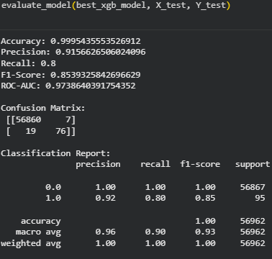
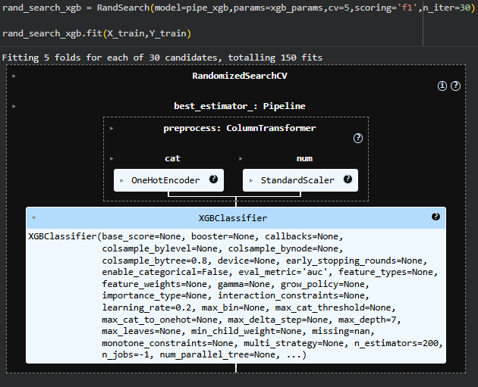
XGBoost
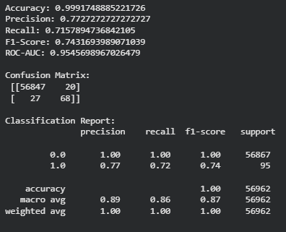
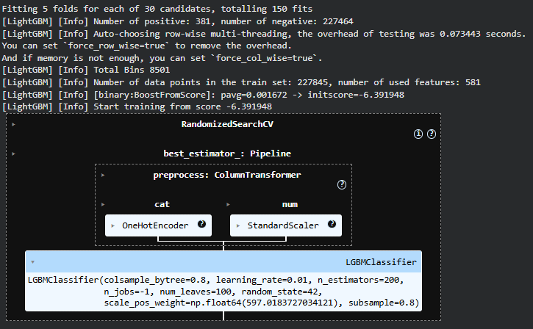
LightGBM

Random Forest Classfier
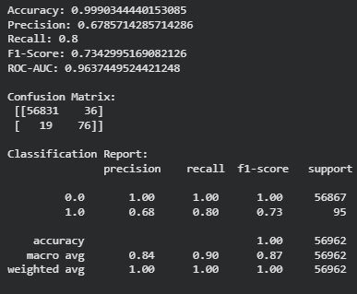
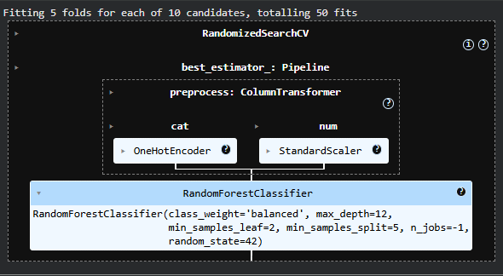

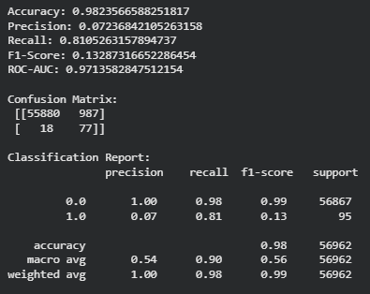
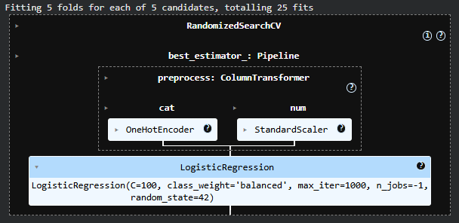
Logistic Regression

After comparing the results, XGBoost performed the best overall, providing a strong balance between fraud detection (recall) and low false positives (precision).
Based on this comparison, XGBoost was selected for further tuning and final deployment.
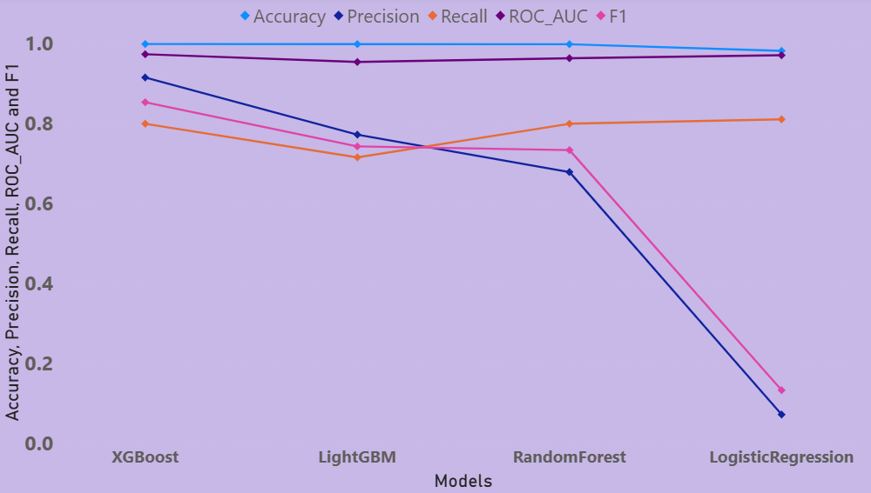
Model Evaluation:
Model | Accuracy | Precision | Recall | F1-score | ROC-AUC
XGBoost | 99.96% | 95% | 81% | 0.88 | 0.97
LightGBM | 99.92% | 77% | 72% | 0.74 | 0.95
Logistic Regression | 98.24% | 7% | 81% | 0.13 | 0.97
Random Forest | 99.90% | 68% | 80% | 0.73 | 0.96
Key Features:
- Observations
- XGBoost balanced everything the best. It caught most frauds with only 7 false alarms.
- LightGBM was slightly lower in recall and precision.
- Logistic Regression had very low precision despite decent recall.
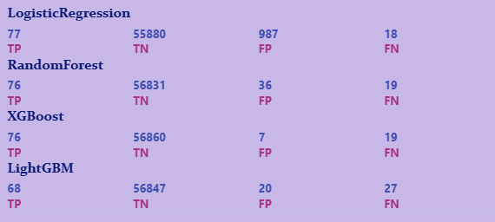
- Random Forest performed well but slightly behind XGBoost.
Model Tuning and Evaluation
- XGBoost Hyperparameter Tuning
- Used RandomizedSearchCV with 30 trials.
- Tuned parameters: n_estimators, max_depth, learning_rate, subsample, colsample_bytree.
- Each trial took around 2–3 minutes; total tuning time ~20 minutes.
- Best parameters found:
- n_estimators = 220
- max_depth = 9
- learning_rate = 0.1
- subsample = 0.65
- colsample_bytree = 0.8
Tuning with XGBoost
To improve the model’s performance, I performed multiple rounds of hyperparameter tuning on the XGBoost model. In total, I conducted 7 tuning experiments by adjusting key parameters such as tree depth, number of estimators, learning rate, and sampling ratios.
- The tuning process helped improve the model’s balance between catching frauds and reducing false alarms.
- The final tuned model achieved the best overall performance, especially in terms of F1-score and recall, making it suitable for real-world deployment.
The following image show the comparisons from each tuning experiment.
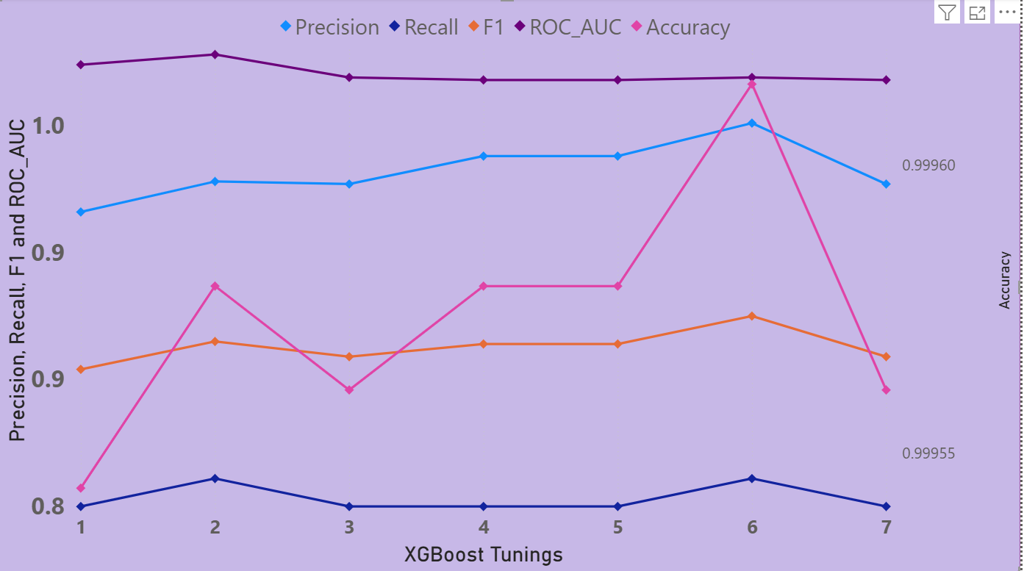

A/B Testing:
- SMOTE vs SCALE_POS_WEIGHT
- Tried SMOTE to balance the dataset by creating synthetic fraud samples.
- SMOTE results: higher recall (83%) but more false positives (12).
- scale_pos_weight results: slightly lower recall (81%) but very few false positives (4).
- Precision drops from 0.951 to 0.868 which shows more false alarms.
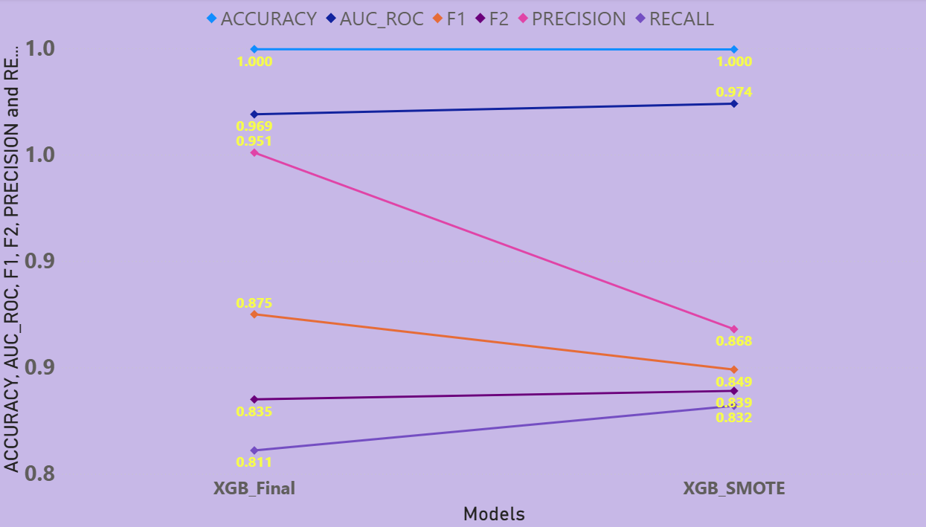
- Chose scale_pos_weight as it is more practical for real-world fraud detection.

Final Model Performance
Metrics |  | Confusion Matrix
Accuracy | 99%
Precision | 95% | True Negatives | 56,863
Recall | 81% | False Positives | 4
F1-score | 88% | False Negatives | 18
F2-score | 84% | True Positives | 77
ROC-AUC | 97% |  | 7
Final Observation
- Tuning significantly improved the model.
- The final XGBoost model detects most frauds while keeping false alarms very low.
- This balance makes the model reliable and ready for production use.
Feature Importance
- I have checked the Top 5 features :
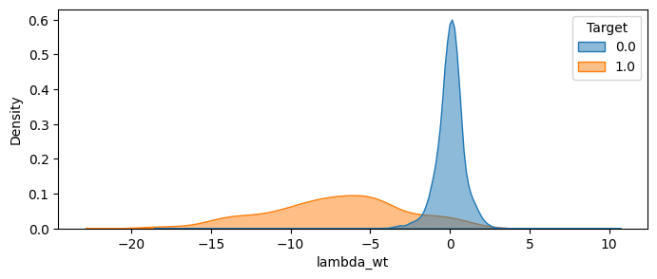
- lambda_wt: Very useful for spotting fraud. Normal transactions have values around 0 (like 0.05 or 0.49). Fraud transactions have very low or negative values (like -7 or -10).
- For example, -8 often means fraud, while +3 means normal.
- Group features (like Grp423, Grp212, Grp321): These groups mostly have normal transactions, so the model sees them as safe. This makes them important for decisions.

Production Deployment
- Model Preparation for Production
- Created a custom class (ProdDataPrep) to handle new incoming data.
- This class adds missing-value flags, merges base tables, and drops the ID column.
- Built a complete pipeline with preprocessing steps and the XGBoost model
Model Saving
- Trained the final model on full training data.
- Saved the trained pipeline as: ATM_FRAUD_PREDICTOR_TRAINED.pkl
- This is for the cleaned training data, so it skips cleaning steps (since the data is already ready).
- I also created a second file, ATM_FRAUD_PREDICTOR.pkl, as a dedicated pipeline.
- This one includes cleaning steps (like adding flags and merging tables) for new, raw data. It makes it easy to use on fresh data without extra work.
- The second one is better for real-world use on new data.
Steps To Load And Run:
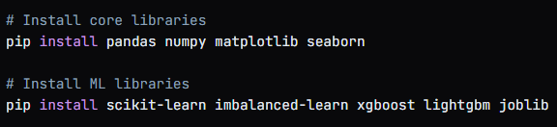
- Step 1 : Import Libraries
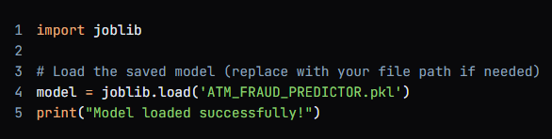
- Step 2 : Load the Model click here For Model.pkl
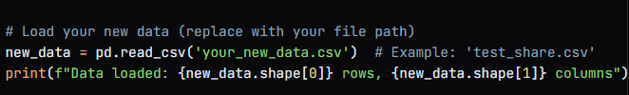
- Step 3 : Load the Data click here For Datasets
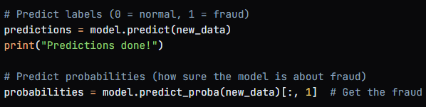
- Step 4 : Predictions
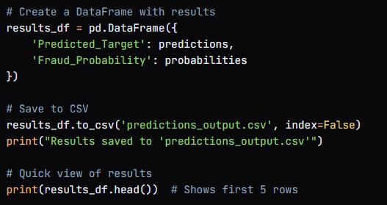
- Step 5 : Save the File

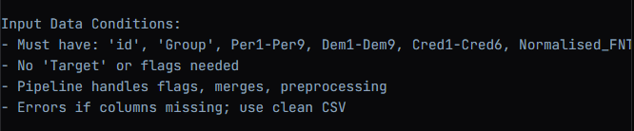
User Data Conditions:
Performance on Unseen Data
- Tested the model on completely unseen data (56,962 transactions).
- Actual fraud cases: 82
- Model predicted: 83 fraud cases
- Only 1 normal transaction was incorrectly flagged as fraud.
- Only 2 fraud cases were missed.
Final Observation
- Very few false alarms and high fraud detection rate.
- The model is stable, efficient, and ready for real-world deployment.
Challenges Faced and How I Tackled Them
- Large Datasets Crashing the System
- Direct merging increased rows from 227,845 to over 5 million and crashed the system.
- I solved this by creating unique base tables before merging, keeping the final dataset at 284,807 rows.
- 2. Imbalanced Data
- Fraud cases were very rare, causing the model to miss frauds.
- I used scale_pos_weight , which improved recall score.
- 3. Duplicates and Missing Values
- Duplicates and nulls could bias the model.
- I removed 55,349 duplicate rows, filled 71,543 missing values with -500, and added flag columns.
- 4. Slow Model Training
- Model training and tuning took 20–35 minutes.
- I used RandomizedSearchCV with 30 trials and enabled verbose output to track progress.
- 5. Weak Feature Correlations
- Most features showed low correlation with the target.
- I relied on feature importance, where lambda_wt and group features showed meaningful impact.
- 6. Production Data Handling
- New data needed the same preprocessing steps.
- I built a reusable pipeline and tested it successfully on 56,962 unseen records.
Conclusion
This project successfully built an XGBoost fraud detector with high precision (95%) and recall (81%), minimizing false positives for customer satisfaction.
Key achievements:
- Handled 1.4M+ rows via Parquet and unique base tables.
- Achieved 88% F1-score on imbalanced data using scale_pos_weight.
- Deployed a production pipeline predicting 83/82 frauds on unseen data.

Project Resources:
Datasets: https://github.com/sobansaidata07/ATM_FRAUD_ML/tree/main/Atm_Fraud_datasets
Model & PKL: https://github.com/sobansaidata07/ATM_FRAUD_ML/tree/main/Atm_Fraud_Model
Reports : https://github.com/sobansaidata07/ATM_FRAUD_ML/tree/main/Atm_Fraud_Powerbi

